HSE University Guidebook
2022
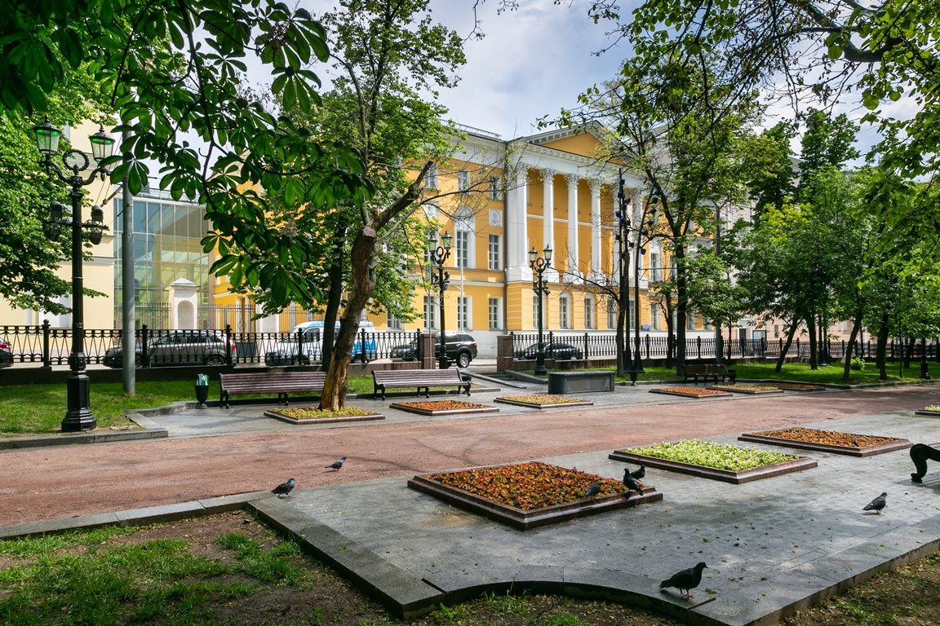
Contents

Before arrival 3
Visa 3
Insurance Policy 3
Safety tips 3
Upon arrival 3
Border and passport control 3
Registration 3
Getting to Moscow 3
Airports 3
Metro system 4
Moscow Metro map 4
Taxi 4
Getting around 5
11 Pokrovsky Bulvar 5
Dining 8
Useful information 12
Internet access 12
Bookstores 12
Currency and money 12
Payment cards 12
ATM / cash machines 12
Useful links 12
Phone Calls 13
Exploring Moscow 13
Places of interest: 13
Entertainment in Moscow 14
If you plan to visit St. Petersburg 14
If you plan to visit Nizhny Novgorod 15
If you plan to visit Perm 15

Before arrival

Visa
To apply for a Russian visa, please:
1. Find the nearest local Russian Consulate by using the interactive map with the list of consulates - “Russia in international relations” at: http://www.mid.ru/en/main_en; 2. Contact the appropriate consulate.

Please be informed that your passport must be valid for a minimum of six months after the visa’s expiry date and have at least two blank two-page spread to attach the visa, as well as include arrival and departure stamps in it.

Insurance Policy
Before coming to Russia, we kindly recommend you to check that your insurance plan is valid in the Russian Federation and contact your insurance company to find out how to use it while in the country.

Safety tips
Please always keep the following documents with you: passport with valid visa, migration card, registration slip, and boarding pass.

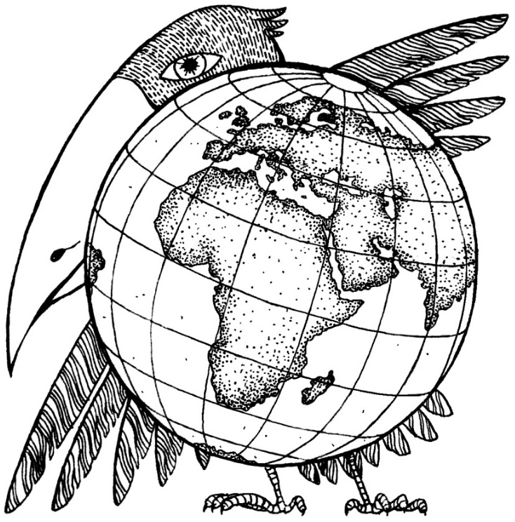
Upon arrival

Border and passport control
Please take your migration card at Passport Control when entering Russia and return it when leaving the country.
If your card is lost, immediately contact the HSE Visa and Registration Centre (https://visa.hse.ru/en/) to obtain a new migration card.

HSE Visa and Registration Centre E-mail: visa-registration@hse.ru Website: https://visa.hse.ru/en
Address: D005/D006, Building D, 11 Pokrovsky Bulvar, Moscow Office hours: Monday-Friday, 10.00am-7.00pm

Registration
Please note that every holder of a foreign national passport must be registered upon their arrival to Russia.
If you are staying for more than seven business days, you must apply for registration.
Most major hotels will provide this service automatically. Please inquire at reception for this service.
If you plan to visit several cities in Russia, you must register at every new destination city within seven business days upon arrival.

Getting to Moscow

Airports
There are four international airports in Moscow: Sheremetyevo, Domodedovo, Vnukovo, and Zhukovskiy. Aeroexpress trains run out of the first three airports. This is quick and safe way to reach the city centre without any traffic jams. You can buy tickets at terminals in the airport or online at https://aeroexpress.ru/en/aero.html. The ticket price varies from RUB 450 (~EUR 6) to RUB 1400 (~ EUR 18).
You can use the Aeroexpress service from 5.14 am until 12.30 am, but we advise that you check the train schedule before your trip.

Metro system
The metro is the easiest and the most reliable way to get around Moscow. It operates from 5.30 am until 1.00 am.
Fares
Type of ticket | Price, in roubles
Underground, monorail, bus, trolley and tram
1 trip¹ | 61
“Ediniy” (Единый), no limit pass, 1 day² | 265
“Ediniy” no limit pass, 3 days² | 500
“Ediniy” no limit pass, 30 days² | 2360
“Koshelek” on the “Troyka” Card³ | 46
Notes:
¹ valid for 5 days;
² smart-card is blocked for 7 minutes after passing the turnstile;
³ the cost of the “Troyka” card is 50 rubles; upon return, its cost (50 rubles) will be refunded.

There is a first-aid post and police station at every metro station.

Moscow Metro map
We kindly recommend that you download the “Yandex Metro” app (available in English), which provides a metro map and information about stations, as well as the ability to calculate travel times. You can download the application from Google Play or App Store on your mobile device.

Taxi
You can also use taxi services to travel to the city from the airport.

The following companies are equipped with English-speaking operators:
  - Angel-Taxi, tel. +7 (495) 956 0800
An airport transfer should cost from RUB 2,600. Note: 60 minutes of gratis waiting after your scheduled landing time. You can book a taxi in advance online at http://www.angel-taxi.com.
  - LingoTaxi, tel. +7 (495) 204 21 34
LingoTaxi offers airport transfers in Moscow. All LingoTaxi drivers speak English. An airport transfer should cost from RUB 2,200. You can book a taxi in advance online at: https://lingotaxi.com.

You can also use the mobile taxi apps downloaded to your mobile devise from App Store or Google Play.

You can order a taxi with following apps:
- Uber;
- Yandex Taxi;
- Gett (Get Taxi).
These apps have English interface but most drivers do not speak English.

Please be aware that taxis can be quite expensive in Moscow, as well as very slow because of the city’s heavy traffic jams. Also, do not get into unknown taxis. We only recommend taking pre-booked taxis.

Getting around
HSE University has three buildings in the Moscow city centre – at 9/11 Myasnitskaya, 20 Myasnitskaya, and 11 Pokrovsky Bulvar.
The buildings on Myasnitskaya Ulitsa are located opposite each other and easily accessible by subway with the following stations just 5–10 minutes away: Lubyanka Metro (red line) and Chistye Prudy Metro (red line).

  - Chistye Prudy Metro Station: exit to Myasnitskaya Ulitsa (Мясницкая улица), which you should follow towards the city centre. 11 Myasnitskaya Ulitsa will be on your right. Estimated walking time: 7 minutes;
  - Lubyanka Metro Station: exit to Myasnitskaya Ulitsa (Мясницкая улица), which you should follow to:

    - 11 Myasnitskaya Ulitsa will be on your left. Estimated walking time: 5-7 minutes;
    - 20 Myasnitskaya Ulitsa is just across from 11 Myasnitskaya Ulitsa and a few metres up the street. Estimated walking time: 5-7 minutes.

11 Pokrovsky Bulvar
The HSE University Complex at Pokrovka (Pokrovsky Bulvar) is one of Russia’s most modern academic facilities, with three colossal atriums connected with various historic buildings forming a single space. For more information and a map, please visit the page of the building: https://www.hse.ru/en/buildinghse/pokrovka/.

Also, we kindly recommend that you download the app “Вышка навигация. National Research University Higher School of Economics”, which provides a map of the HSE buildings. The app is available at Google Play and the AppStore.

Entrances to the complex

Three entrances are currently open:
Entrance 1: from Pokrovsky Bulvar, closer to where it intersects with Vorontsovo Pole;
Entrance 2: closer to the intersection of Pokrovsky Bulvar and Durasovsky Pereulok (convenient if you are coming from Chistye Prudy, Turgenevskaya, and Sretensky Bulvar Metro Stations, or if you are coming from HSE University’s buildings on Myasnitskaya, Tryokhsvyatitelsky/Khitrovsky, Potapovsky, or Slavyanskaya Ploshad);
Entrance 3: from Durasovsky Pereulok, near the Cultural Centre (this is convenient if you are coming from the Kurskaya and Chkalovskaya Metro Stations).

Ways of getting to Pokrovsky Bulvar

ˇFrom Kitay Gorod Metro. There are many exits in Kitay Gorod Metro Station. You need Exit № 8. Then follow the map below:
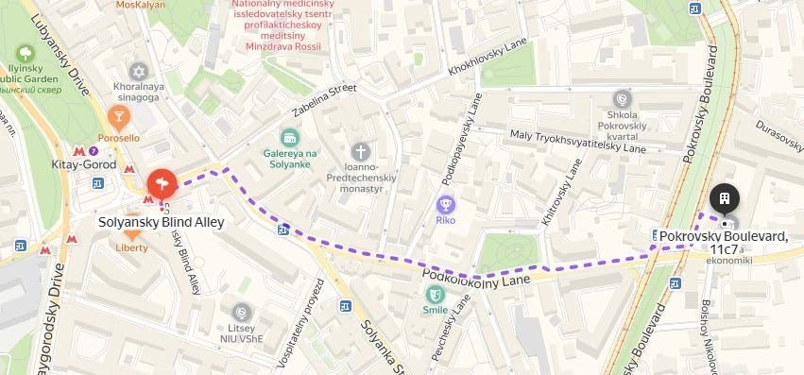

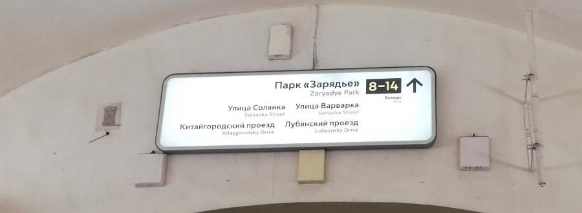
ˇFrom Chkalovskaya and Kurskaya Metro Stations
From Chkalovskaya Metro Station and Kurskaya Metro Station (ring line), take Exit № 6. Estimated walking time: 14-15 minutes

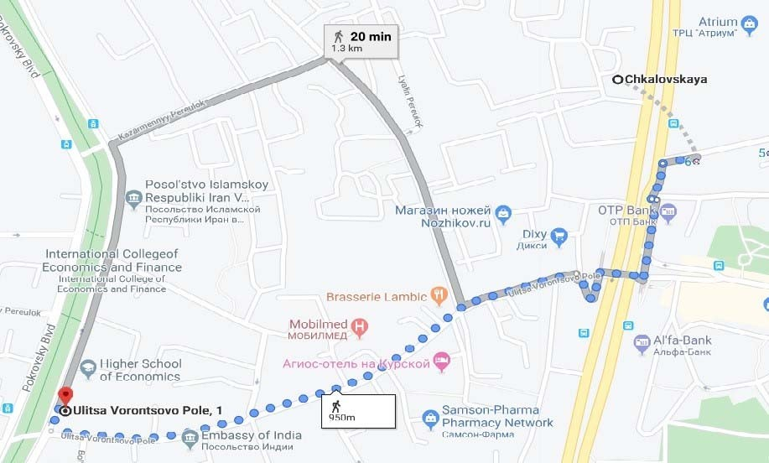

ˇFrom Chistye Prudy Metro Station (take Exit № 1)
On foot: Walk down the boulevard past the ponds of Chistye Prudy, then cross Pokrovka. Walk past Khokhlovskaya Ploshad and go along Pokrovsky Bulvar. The HSE building is on the left. Estimated walking time: 18 minutes.
By tram: The tram stop for Vorontsovo Pole is to the right from the metro exit. You can choose any of the three tram routes: Tram № 39 goes to Universitet Metro Station; Tram А goes to Oktyabrskaya Metro Station; Tram № 3 goes to Chertanovskaya Metro Station. Bus 3Н follows the same route. Travel time: 12 minutes.
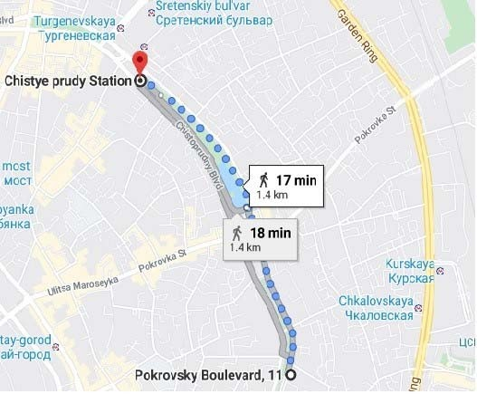
Accommodation

The following hotels are conveniently located near the HSE administrative buildings and the most popular attractions in Moscow.

St. Regis Moscow Nikolskaya, 5*
Just steps away from the Red Square, the Bolshoi Theatre and St. Basil's Cathedral, The St. Regis Moscow Nikolskaya combines a rich cultural legacy with modern design. It is a 22-minute walk from HSE University at Pokrovka.
Website: http://www.stregismoscow.com E-mail: moscow@stregis.com

Ermitage Hotel, 4*
A 20-minute walk from the Red Square and the Kremlin, this hotel offers rooms with mini-bars, free WiFi, a sauna and a fitness centre. Trams are 50m away from Ermitage. Kursky Train Station is a 10-minute walk away, while Kitay Gorod Metro Station, Kurskaya Metro Station, as well as Chkalovskaya Metro Station, are a 15-minute walk from the hotel. It is also a 2-minute walk from the HSE administrative building. Website: https://ermitagehotel.ru
E-mail: 5064545@mail.ru

Hitrovka Hotel, 4*
Hitrovka Hotel is a 7-minute walk from Kitay Gorod Metro Station. Each room at Hitrovka Hotel is decorated in a classic style. The Bulvar Ring starts 350m from Hitrovka Hotel, while the Red Square is in 20 minutes of walk. The Belorussky Railway Terminal is a 10-minute metro ride from the hotel, offering a direct link to Sheremetyevo Airport. Tagansky District is also a great choice for those interested in convenient public transport, parks and city walks. It is a 6-minute walk from the HSE building. Website: http://hitrovkahotel.com/en E-mail: guest@hitrovkahotel.com

Boutique Hotel Chemodanov, 4*
Located 2.4km from the Red Square, Boutique Hotel Chemodanov features views of the city. GUM Department Store is 2.5km from the accommodation, while Red Square is 2.5km away. Basmanny District is a great choice for travelers interested in ambience, walking and using convenient public transport. It is a 13- minute walk from the HSE administrative building.
Website: http://boutique-chemodanov.best-moscow-hotels.com/ru

Bentley Hotel, 3*
This hotel is located on Pokrovka Ulitsa, one of the oldest streets in Moscow. It is just 10 minutes on foot from Kurskaya Train Station. The hotel has an American-style diner with a terrace, Frendy's, on its second floor. Basmanny District is a great choice for travelers interested in ambience, strolls and easy access to public transport. Furthermore, it is just a 13-minute walk from HSE administration building.
Website: https://bentleyhotel.ru
E-mail: hotel@bentley.cc, info@bentleyhotel.ru

Red Brick Hotel Kitay Gorod, 3*
The Red Brick Hotel Kitay Gorod is situated in a historic 18th century building, 1.4km from Saint Basil's Cathedral. Guests can enjoy the on-site restaurant. Furthermore, the GUM Department Store is 1.4km from this hotel, while Lenin’s Mausoleum is 1.5km away. The nearest airport is Sheremetyevo International Airport, 27km from this location.
Basmanny is a great choice for travelers interested in ambience, walking and convenient public transport. It is a 5-minute walk from the HSE administrative building.
Website: http://redbrickhotel.com, E-mail: reservation@redbrickhotel.com

Dining
Dining in Moscow can be quiet varied. The following cafes are located in and near 11 Pokrovsky Bulvar, near Kurskaya Metro and Kitay Gorod Metro Stations.

In the HSE University building (11 Pokrovsky Bulvar)
- HSE Dining Hall in building N
- Cafeteria (1st floor) and Restaurant (2nd floor) in building K
- Coffeehouse in building F, first floor of the Southern Atrium
- Joeffrey’s Coffee in building S (ground floor)
- Café «Grusha» in building S

Near HSE University
№ | Under 9 Euro | До 700 руб. | Address
1. | “Projector “Coffee | Кофейня «Прожектор» | Яузский бул., 1  (1 Yauzskiy Bulvar)
2. | “Syr i coffee” Café | Кафе «Сыр и кофе» | Хитровский пер., 3/1с4  (Building 4, 3/1 Khitrovskiy Pereulok)
3. | “Bufet-obed” Cafe | Кафе «Буфет-обед» | Хитровский пер., 3/1с4  (Building4, 3/1с Khitrovskiy Pereulok)
4. | “El cafe” Café | Кафе «Эль кафе» | Казарменный пер., 6, стр. 1  (Building 1, 6 Каzarmenniy Pereulok)
5. | “Vinograd” Café | Кафе «Виноград» | Подкопаевский пер., 4А  (4A Podkopaevskiy Pereulok)
 | Under 14 Euro | До 1100 руб.
6. | “Friends. Сoffee and Kitchen” Café | Кафе  «Френдс. Кофе энд китчен» | ул. Покровка, 20/1с1  (Building 1, 20/1 Pokrovka Ul. )
7. | “M-Point” Bar | Бар «М -поинт» | Покровский бул., 8, стр. 2А  (Building 2А, 8 Pokrovsky Bulvar)
 | Under 21 Euro | До 1600
8. | “Dom 16” Restaurant | Ресторан «Дом 16» | Покровский бул., 16-18с4-4А  (Building 4-4А, 16-18 Pokrovsky Bulvar)
9. | “Brasserie Lambic” Restaurant | Ресторан «Брассери Ламбик» | ул. Воронцово Поле, 11/32с2  (Building 2, 11/32 Vorontsovo Pole Ul.)
10. | “Latuk” Restaurant | Ресторан «Латук» | Яузская ул., 1/15с2  (Building 2, 1/15 Yauzskaya Ul. )
11. | “Staraya Gruziya” Restaurant | Ресторан «Старая Грузия» | Подколокольный пер., 16/2 стр 1  (Building 1, 16/2 Podkolokolniy Pereulok)

Near metro Kurskaya
№ | 4 Euro till 26 Euro | От 300 руб. До 2000 руб. | Address
12. | “Atrium” Trade Center has a food-court and different cafes  and restaurants | В ТЦ «Атриум» есть фудкорт и разные кафе и  рестораны | ул. Земляной Вал, 33  (33 Zemlyanoy Val Ul.)

Near metro Kitay-Gorod
№ | Under 7-8 Euro | До 500-600 руб. | Address
13. | “Svoy klyuch” Anticafé | Антикафе «Свой ключ» | ул. Солянка, 4, стр. 4, 8 выход из метро Китай-город  (Building 4, 4 Solyanka Ul. Exit №8 from Kitay Gorod Metro)
14. | “Cofix” Café | Кафе «Кофикс» | ул. Солянка, 2/6с1, 8 выход из метро Китай-город  (Building 1, 2/6 Solyanka Ul. Exit №8 from Kitay Gorod Metro)
15. | “Lyudi kak lyudi” Café | Кафе «Люди как люди» | Солянский тупик, 1/4, 8 выход из метро Китай-город  (1/4 Solyanskiy Tupik. Exit №8 from Kitay-Gorod Metro)
16. | “Grabli” Restaurant | Ресторан «Грабли» | ул. Солянка, 1/2с1, 8 выход из метро Китай-город  (Building 1, 1/6 Solyanka Ul. Exit №8 from Kitay Gorod Metro)
17. | “Prime” Bistro | Бистро «Прайм» | ул. Солянка, 4, стр. 4, 8 выход из метро Китай-город  (Building 4, 4 Solyanka Ul. Exit №8 from Kitay Gorod Metro)
18. | “Surf Coffee” Café | Кафе «Cерф кофе» | ул. Солянка, 1/2с1  (Building 1, 1/2Solyanka Ul.)
19. | “Сentral market at  Мaroseyka” Restaurant | Ресторан  «Центральный рынок на Mаросейке» | ул. Маросейка, 4/2с1. 5 или 6 выход из метро Китайгород  (Building 1, 4/2 Maroseyka Ul., . Exits №5 and № 6 from KitayGorod Metro)
20. | “Bushe” Cafe | Кафе «Буше» | ул. Солянка, 1/2, 8 выход из метро Китай-город  (1/2 Solyanka Ul. Exit №8 from Kitay Gorod Metro)
 | Under 9 Euro | До 700 руб.
21. | “Shokoladnitsa” Café | Кофейня  «Шоколадница» | Большой Спасоглинищевский пер., 9/1с16, 8 выход из метро Китай-город  (Building 16, 9/1 Bolshoy Spasoglinishevskiy Pereulok. Exit №8 from Kitay Gorod Metro)

22. | “Hleb Nasuschniy” Café | Кафе «Хлеб Насущный» | ул. Солянка, 1/2  (1/2 Solyanka Ul.)
23. | “Bardak” Turkish cafe | Турецкое кафе «Бардак» | ул. Маросейка, 6/8, стр 1  (Building 1,6/8, Maroseyka ul.)
 | Under 13-20  Euro | От 1000 руб. до  1500 руб.
24. | “Casa Leone” Restaurant | Ресторан «Каса леон» | Лубянский пр., 15, стр. 2. 7 выход из м. Китай-город  (Building 2, 15 Lubyanskiy Proezd. Exit №7 from Kitay Gorod Metro)
25. | “Justa Pasta” Pizza Restaurant | Пиццерия «Джаста Паста» | ул. Солянка, 2/6с1.  8 выход из м. Китай-город  (Building 1, 2/6 Solyanka Ul. Exit №8 from Kitay Gorod Metro)
26. | “San Martsano” Restaurant | Ресторан «Сан марцано» | ул. Солянка, 2/6С1  8 выход из м. Китай-город  (Building 1, 2/6 Solyanka Ul. Exit №8 from Kitay Gorod Metro)
27. | “True Cost Progektor” Restaurant | Ресторан «Тру Кост Прожектор» | Славянская площадь, 2/5/4с3 8 выход из м. Китай-город  (Building 3, 2/5/4 Slavyanskaya Ploshad. Exit №8 from Kitay Gorod Metro)
28. | “Pizza 22  centimeters” Restaurant | Пиццерия  «Пицца 22 сантиметра» | ул. Солянка, 1/2  (1/2 Solyanka Ul.)
29. | “Blink” Restaurant | Ресторан «Блинк» | ул. Солянка, 1/2С1  (Building 1, 1/2 Solyanka Ul.)
30. | “Stariy Sichuan” Restaurant | Ресторан «Старый Сычуань» | Лубянский пр., 25, стр. 2.  9 и 10 выходы из м. Китай-город  (Building 2, 25 Lubyanskiy Proezd. Exits №9 and №  from Kitay-Gorod Metro)

Additional information:
The bars and restaurants by famous Russian restaurateur Arkadiy Novikov (American cuisine, Italian cuisine, Pan-Asian cuisine, Turkish cuisine, Japanese cuisine, Caucasian cuisine, Russian cuisine, Middle East cuisine and etc) can be checked on the following link: https://www.novikovgroup.ru/

Useful information

Internet access
EduRoam WiFi is available in all HSE buildings.

WiFi for HSE guests is also available at all University buildings: Network name: HSE
Login: hseguest Password: hsepassword

Bookstores

BookVyshka
(БукВышка)

Biblio Globus
(Библио-глобус)

Dom Inostrannoi Knigi (House of Foreign Books, Дом иностранной книги)

HSE Book Shop, Foreign Language Books 20 Myasnitskaya Ulitsa;
11 Pokrovsky Bulvar
Building 1
6/3 Myasnitskaya Ulitsa
18/7Kuznetskiy Most

Currency and money
The official monetary unit in Russia is the rouble. You can buy roubles at exchange offices in banks. You can only receive cash in roubles when withdrawing money from your bankcard at ATM machines in Russia. ATMs may charge extra fees for cash withdrawals.

Please note that exchanging currency at the airport is more expensive. In the city, the exchange rate is usually more favorable.

Payment cards
Payment cards, especially Visa, MasterCard and American Express, are widely accepted at shops and restaurants throughout Moscow.

ATM / cash machines
A VTB 24 ATM machine is situated:
- on the ground floors at 11 Myasnitskaya Ulitsa and 20 Myasnitskaya Ulitsa;
- there are two VTB ATMs – near Entrance 2 and Entrance 3 at 11 Pokrovsky Bulvar;
- there is an ATM at the Faculty of Law on 3 Bolshoy Tryokhsvyatitelsky Pereulok (3-4-minute walk from the Pokrovka Complex).

A Sberbank ATM machine is situated:
- on the ground floor at 20 Myasnitskaya Ulitsa;
- there are many Sberbank ATMs in the bank’s office at 41 Zemlyanoy Val, Building 1 (on the way to Pokrovka from the Kurskaya and Chkalovskaya Metro Stations).

Other ATM machines can easily be found at several bank branches on Myasnitskaya Ulitsa:
- Raiffeisen Bank ATM (22/2/5 Myasnitskaya Ulitsa); ▪ Alfa-Bank ATM (13 bld. 1 Myasnitskaya Ulitsa).

Useful links
Constantly updated and rated as one of the most popular and reliable sources of information about living and travelling in Russia: http://waytorussia.net/.
The Moscow Times, a daily English-language newspaper, featuring objective, reliable news on business, politics, sports, and culture in Russia: https://themoscowtimes.com.

Phone Calls
The Russia country code +7 allows you to call Russia from another country. The area codes for Moscow are 495 and 499. Moscow phone numbers are usually given with the area code. If no area code is indicated, one should use 495 for Moscow. For phone calls to Moscow from outside of Russia, dial the international access code +7 495 (or +7 499) plus a seven-digit phone number. When in Moscow, also dial +7 495 (or +7 499) and the seven-digit number.

Exploring Moscow

Places of interest:
- Moscow Kremlin
- Red Square
- St. Basil’s Cathedral
- Armory Chamber (at the Kremlin)
- Alexandrovsky Garden
- State Historical Museum
- GUM (Main Department Store)
- Bolshoi Theatre
- Moscow Tchaikovsky Conservatory
- Pushkin State Museum of Fine Arts
- Cathedral of Christ the Savior

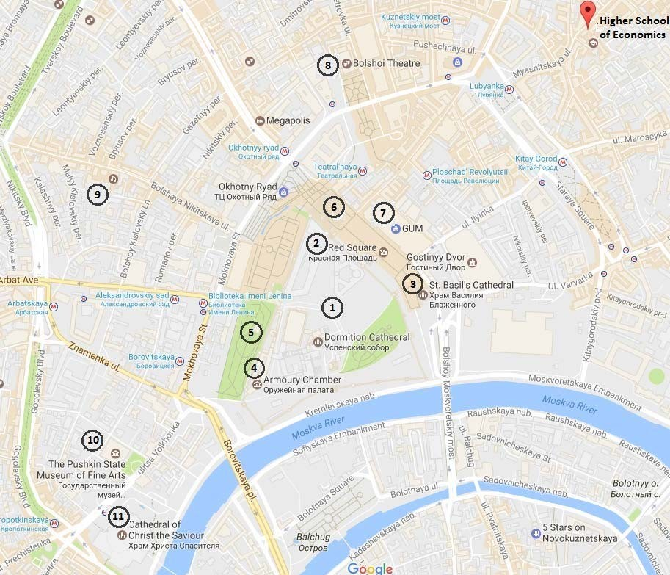

More information is available at https://www.hse.ru/en/recommends/places.
You can also check the following websites to find more information about getting around Moscow and Russia:
- My Destination Moscow: https://www.mydestinationmoscow.com ;
- Moscow in Your Pocket: https://www.inyourpocket.com/moscow (where you can also download the app on your mobile device).

Entertainment in Moscow
You can also check the following websites to find more information about entertainment in Moscow:
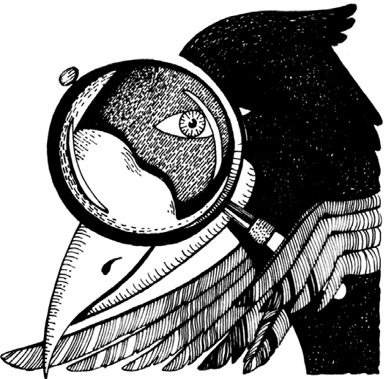
- Tourist portal: https://discover.moscow/en/
- Pioneer Cinema (Pioner) - movies in their original language with Russian subtitles: https://pionercinema.ru/en/
- GUM-Cinema: https://gumrussia.com/kinozal/
- Bolshoi Theatre official site:
https://www.bolshoi.ru/en/
- Moscow Conservatory official site:
http://www.mosconsv.ru/en/
- Tickets for concerts, theatres, festivals, sports, events & attractions: https://www.parter.ru
- “Luzhniki” Olympic Complex-one of the largest sport grounds in Russia and the world: https://eng.luzhniki.ru/about/complex/

If you plan to visit St. Petersburg
It is convenient to use the train to get from Moscow to St. Petersburg. Tickets can be booked online on http://pass.rzd.ru/main-pass/public/en. With the high-speed Sapsan train, you can reach St. Petersburg in just four hours. Trains depart from Leningradsky Railway Station (Ленинградский вокзал), which is situated near Komsomolskaya Metro Station (brown line or red line).
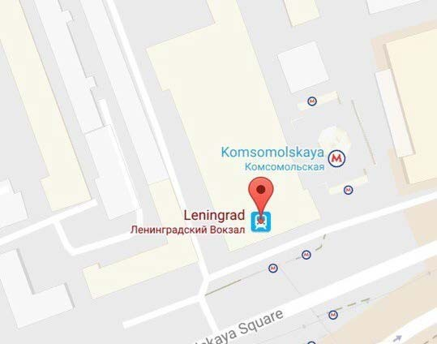
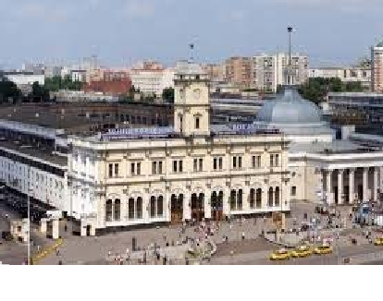

If you plan to visit Nizhny Novgorod
You can get to Nizhny Novgorod by train. Tickets can be booked online at: http://pass.rzd.ru/mainpass/public/en. With the high-speed trains Strizh or Lastochka, you can reach Nizhny Novgorod in just four hours. Trains depart from Kursky Railway Station (Курский вокзал), which is situated near Kurskaya Metro Station (brown line or dark blue line).
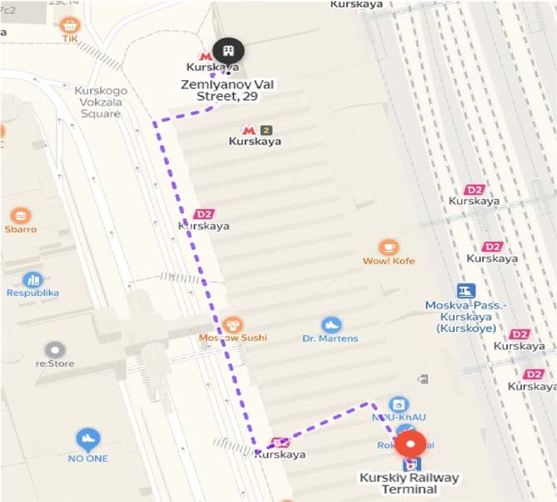
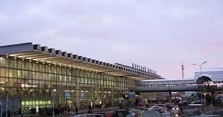

If you plan to visit Perm
You can get to Perm by train. Tickets can be booked online at http://pass.rzd.ru/main-pass/public/en. It takes around 19 hours to reach Perm by train. Trains usually depart from Yaroslavsky Railway Station (Ярославский вокзал), which is situated near Komsomolskaya Metro Station (Lines 1 and 5). You may also get there by plane in three hours.
